
Leukemia Blood Cell Cancer Detection
Kunal Jaiswal(19BCE1321) | Dr. Pattabiraman V| SCOPE

Motivation and Introduction Results
Leukemia is cancer of the body's blood-forming tissues, including the bone marrow and the lymphatic system.  Many types of leukemia exist. Some forms of leukemia are more common in children. Other forms of leukemia occur mostly in adults.Leukemia usually involves the white blood cells. Your white blood cells are potent infection fighters — they normally grow and divide in an orderly way, as your body needs them. But in people with leukemia, the bone marrow produces an excessive amount of abnormal white blood cells, which don't function properly.  Acute lymphoblastic leukemia (ALL) is the most common type of childhood cancer and accounts for approximately 25% of the pediatric cancers.  These cells have been segmented from microscopic images and are representative of images in the real-world because they contain some staining noise and illumination errors, although these errors have largely been fixed in the course of acquisition.  The task of identifying immature leukemic blasts from normal cells under the microscope is challenging due to morphological similarity and thus the ground truth labels were annotated by an expert oncologist.  In total there are 15,135 images from 118 patients with two labelled classes:  Normal cell;  Leukemia blast. | - Our project's end result is to properly diagnose cancer using the iterations acquired, the loss and accuracy graph, and the confusion matrix.  - We've done ten iterations and can see that the loss is reducing with each cycle. The amount of loss is determined by how accurate the model is. So we intended to minimise the loss function, and as a consequence, our model has perfectly dropped the loss value right from the start, and we are getting closer to the minimum with each iteration.  - We have a loss curve that is dropping with each iteration, indicating that loss is being minimised and the best outcome is being achieved. On the other side, we've created an accuracy curve that gets better with each iteration, indicating that our model is growing better at learning.  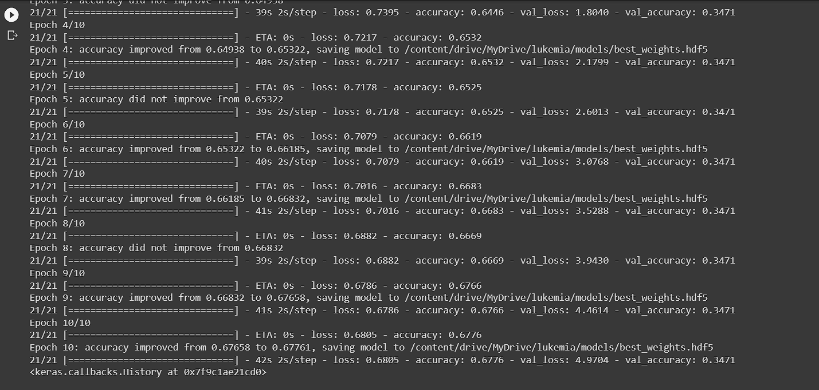
  Algorithm | Accuracy
  Convolutional Neural Network | 67.76%
Scope of the Project
After collecting actionable information from the above analysis, we aim to employ data visualization techniques to create relevant and observable statistics around our analysis. We will use in-built Python modules to achieve the goal as well as employ some indispensable tools present in the Spyder application. Even though the data collection is limited to a few select attributes, our methodology will derive some valuable and infer knowledge from it, which can be used to hence make preventive efforts in these areas.
Methodology
The project followed the depicted Crisp DM technology methodology. Implementation was divided into three different modules:
- Data Pre-Processing Module
- Data Analysis and Visualization
- Data Modelling and Classification Algorithm
In the exploratory data analysis, attributes of images with respect to labels have been analyzed and their dependence on the winning of the candidate in the election has been observed. Apart from the individual status of the candidate, the overall influence of the party has also been considered for data interpretation
For classification, since the data is a categorical dataset, we implement a classification algorithms
- Convolutional Neural Network

The accuracies of each of the algorithm is observed and then a final prediction model is built. The performance evaluation has been done based on hyper – parameter tuning on all the given attributes taken as parameters, followed by constructing a classification report based on the accuracy, precision, recall, support, F-1 score and confusion matrix of all the attributes with their given set of percentage of false negatives and making the prediction model go through the training and testing data. The testing data has been taken as part of a 3 – fold dataset, taking place by considering various other significant factors.
 | Conclusion
The task of identifying immature leukemic blasts from normal cells under the microscope is challenging due to morphological similarity and thus the ground truth labels were annotated by an expert oncologist.
In total there are 15,135 images from 118 patients with two labelled classes:
- Normal cell;
- Leukemia blast.

 | Contact Details
 | kunal.jaiswal2019@vitstudent.ac.in
 | References

Machine Learning in Detection and Classification of Leukemia Using Smear Blood Images: A Systematic Review - Mustafa Ghaderzadeh, Farkhondeh Asadi,Azamossadat Hosseini, Davood Bashash, Hassan Abolghasemi, and Arash Roshanpour

https://corescholar.libraries.wright.edu/knoesis/1137/

https://www.kaggle.com/datasets/andrewmvd/leukemia-classification

